Product category: AC DRIVES (VFD’s)

AC DRIVE COMPANY

OMRON

1. Model name: OMRON-3G3RX2 AC DRIVE

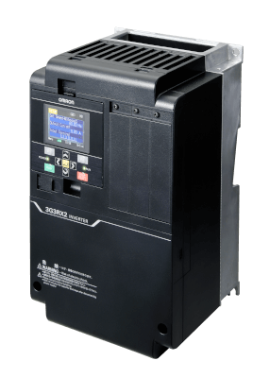

# MODEL NAME : OMRON-3G3MX2-V1 AC DRIVE

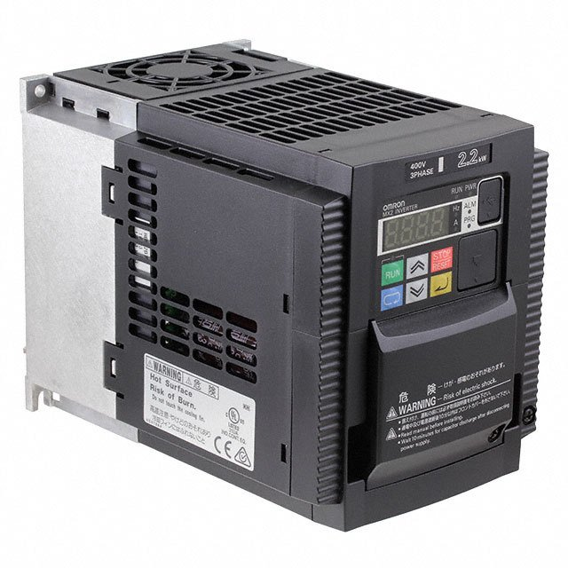

MODEL NAME: ALL OTHER OMRON VFD’S

[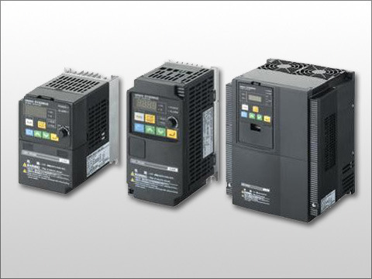](https://www.deltaelectronicsindia.com/industrial-automation/touch-panel-hmi-human-machine-interfaces/tp70p/" \o "TP70P)